IFB299 – Application Design and Development

Personal Portfolio

By Joel Perry, n9173471

# Release 1

## Artefact 1 - Storyboards

Below are the initial designs for the 8 pages in the website. The designs allowed a framework for how the website will look like, allowing assistance when building the website.

|  |  |
| --- | --- |
|  |  |
|  |  |
|  |  |
|  |  |

## Artefact 2 – Sprint Burndown Charts

I constructed the sprint 1 and 2 burndown charts for my group in release 1. The charts show the group a timeline on our progress of the tasks during the two sprints, showing the ideal burndown, our estimate time to complete the tasks and the actual times it took to complete them.

**Sprint 1:**

**Sprint 2:**

## Artefact 3 – Business Letter Research

I conducted research on how to write and format a business letter that we had to write to your developers. The research meant that our group understood how the write the business letter in a formal format.

|  |
| --- |
| **Client Team 94**  James Skidmore – n9146661  Benjamin McColm-Pickford - n8847762  Jonny Vukim - n9470921  Kihoon Seo - n8998949  Katrina Mallett - n9450866  Joel Perry - n9173471    September 13, 2016  Package Delivery Development Team 93  QUT Community Organisation  2 George Street  Brisbane, Queensland 4000    Dear Development Team:  I am writing to you as your client concerning the latest demonstration of your development project. On the 8th of September 2016 your development team demonstrated the latest content and provided an update on the current version of the project and the technical work that has been completed regarding a website for the delivery company owned by Bill.  Firstly, I would like to commend your development team on their preparedness and confidence in the product they had created so far. The demonstration of the project was completed well with no major issues that need to be addressed. Each story card regarding sprint one was also discussed to see whether the stories passed their acceptance criteria or not.  As your client we agreed to a set of expectations which was the content covered in your first sprint. I am glad to inform you that your project team delivered each user story that was agreed to in the sprint plan. Development of each story seemed to have been completed well with all five story cards meeting their acceptance criteria. During the discussion the development team also came across quite confident in their abilities and the work they had completed regarding the acceptance criteria. However, the development team did take longer than expected to complete login services. They stated this was due to lack of experience in this particular area. This was not an issue though as most other tasks were completed ahead of schedule due to their experience in developing those particular aspects of the project. Finally, regarding the expectations the product being developed has surpassed our expectations in nearly all areas and while also delivering business value.  During the product demonstration no technical difficulties occurred as the presentation was presented at the right level for all the stakeholders. The system architecture explained by the developing team was well defined and shown to be suitable for the project with no defects in the presentation detected.  The professionalism of the presentation requires improvement in the future as a more formal and rehearsed presentation is expected throughout the rest of the project, however, all content was covered with quality information. The members presenting the product were coherent and confident in their knowledge of the product to date. Each question regarding the product and how the work was completed was answered to a satisfactory level with every member of the development team seeming to be involved in helping create the product. As the presentation was performed ad hoc it did mean that there were some parts that were probably not discussed to their fullest potential but this can be easily fixed by spending a short time preparing well for the presentation.  In conclusion, the presentation of the product was conducted at a high level by the development team. The demonstration was clearly prepared and provide us, as the client, with knowledge that the project is keeping to the precise time schedule and completing all required story cards with their acceptance criteria. For future presentations it would be helpful if a higher level of professionalism was taken to match the strong content.    Sincerely,  Bill’s Delivery Service Melbourne |

## Artefact 4 – Story Cards

I created 11 story cards as the development team for the event organisation. The story cards were latter used in the sprint 4 to build the website for the client.

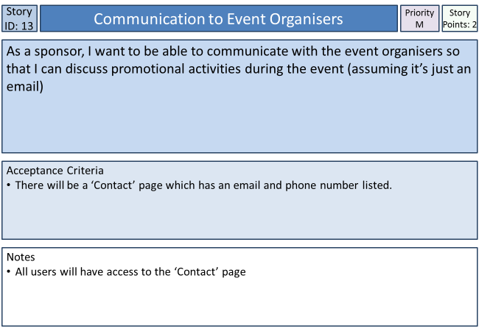

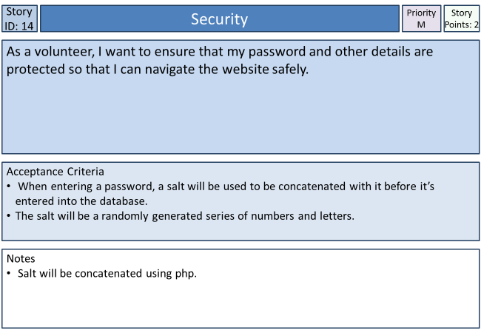

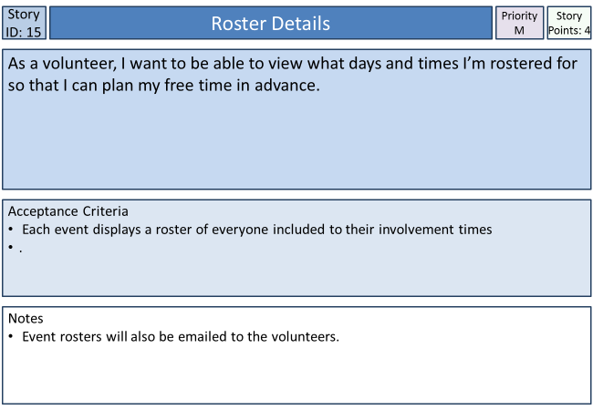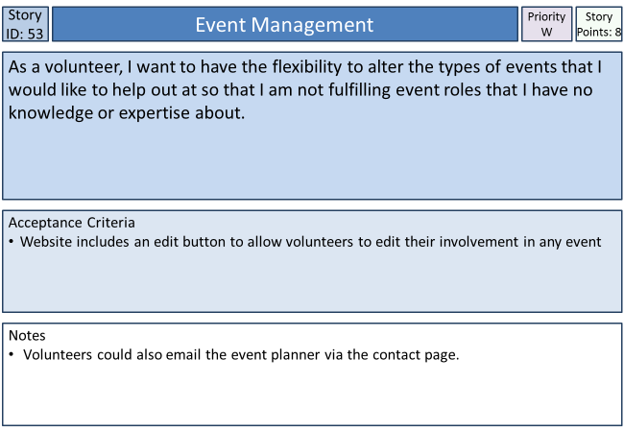 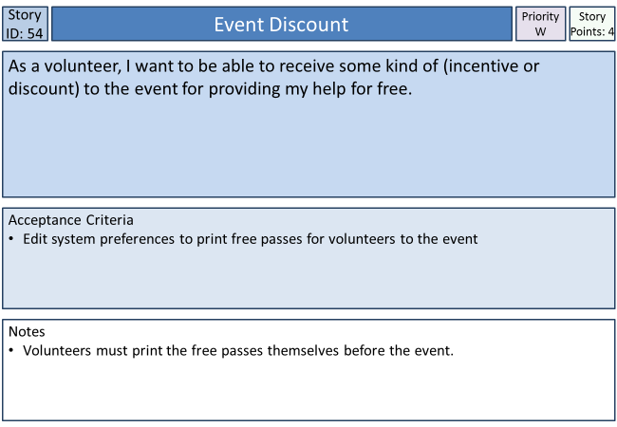 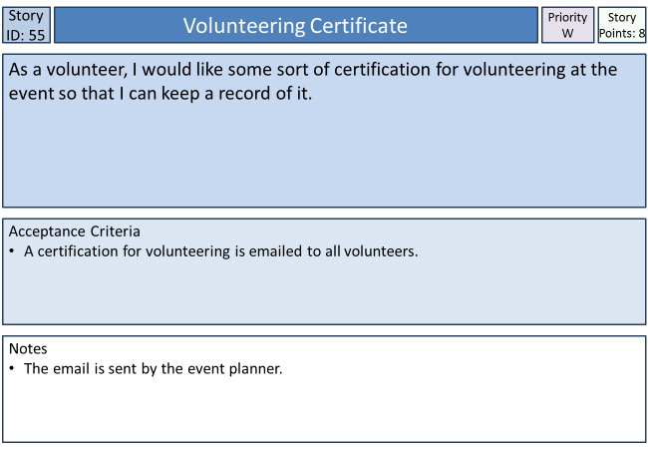 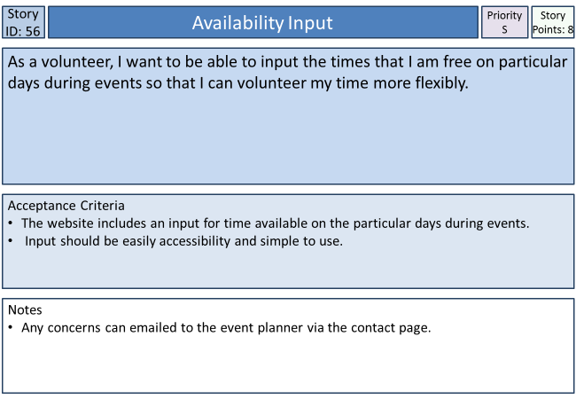 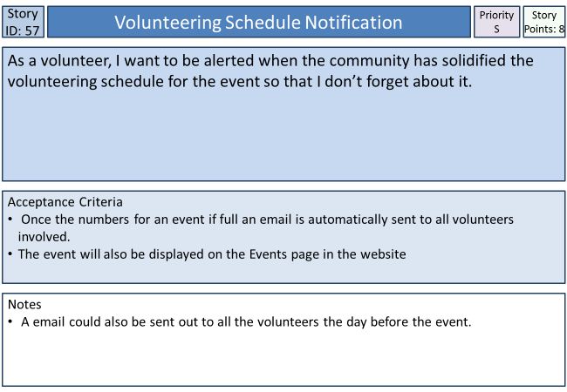 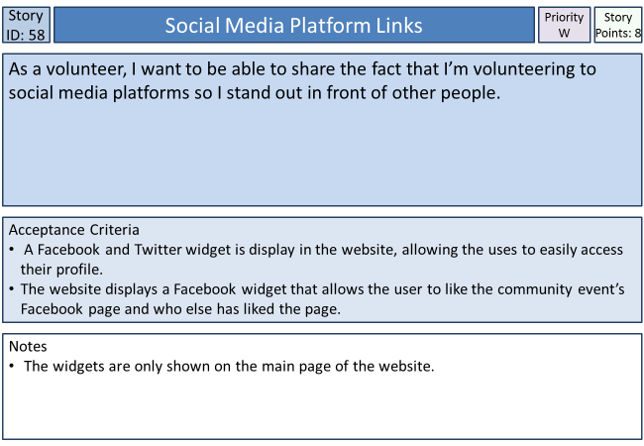 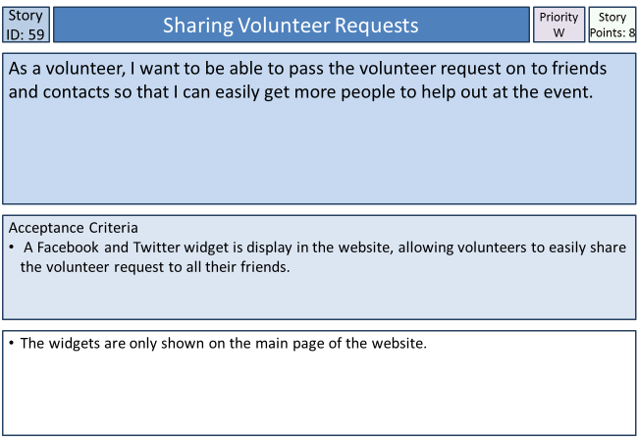

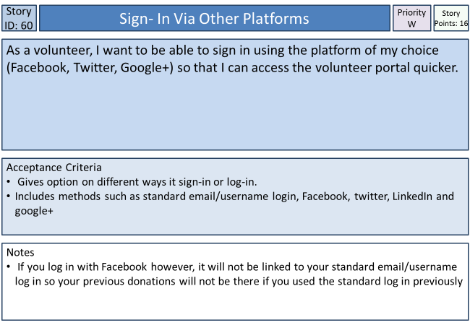

## 

## Artefact 5 – Release 1 Burndown Chart

I built a Release 1 burndown chart based on the stories completed during the four-week period. The chart shows the group how well we performed, and where we fell behind in our work. The chart gives us feedback on how the completed the next release, in that less story points should be taken because we did not finish all of the 35 story point in release 1.

# Release 2

## Artefact 1 – Sprint 3 Planning

In release 2 helped organised the components for sprint 3, what stories to include, what tasks are required for each story and the estimate time it would take to completed the tasks. Organising the sprint allowed the team the understand what was required to completed during the next two week, and provide assistance in a timeframe on how long it will take to finished all the work.

**Sprint 3**

Total Story Points: 34 Total Hours: 36

Current Velocity: 23

## S3: Access to detail of organisation’s members

|  |  |  |  |
| --- | --- | --- | --- |
| **Task ID** | **Task Description** | **Estimate** | **Taken** |
| **T11** | Populate database with members contact details | 2hrs | 2hrs |
| **T12** | Access and display database from event or contact page | 6hrs | 6hrs |
|  | Story Points: 4 Total Hours: | 8hrs | 8hrs |

## S7: Site Security

|  |  |  |  |
| --- | --- | --- | --- |
| **Task ID** | **Task Description** | **Estimate** | **Taken** |
| **T15** | Create login and registration page | 4hrs | 8Hrs |
| **T16** | Security for password and form | 2hrs | 6Hrs |
| **T17** | Form validation (possibly through PHP/JS) | 4hrs | 2hrs |
|  | Story Points: 2 Total Hours: | 10hrs | 16hrs |

## S35: Event information

|  |  |  |  |
| --- | --- | --- | --- |
| **Task ID** | **Task Description** | **Estimate** | **Taken** |
| **T20** | List basic information about events from database (Location, time etc.) | 4hrs | 6hrs |
| **T21** | Display event description and further info(possibly dress code and picture) | 2hrs | 2 Hrs |
| **T22** | Display fundraiser goal and current donation count | 2hrs | 2 Hrs |
|  | Story Points: 4 Total Hours: | 8hrs | 10hrs |

## S05: Visitor Registration

|  |  |  |  |
| --- | --- | --- | --- |
| **Task ID** | **Task Description** | **Estimate** | **Taken** |
| **T31** | Create registration page | 4hrs | 4Hrs |
|  | Story Points:  2 Total Hours: | 4 hrs | 4 hrs |

## S02: Tracking the number of attendees

|  |  |  |  |
| --- | --- | --- | --- |
| **Task ID** | **Task Description** | **Estimate** | **Taken** |
| **T32** | Add counter to Attendance button | 1 Hr | 1hr |
| **T33** | Display Counter | 1 Hr | 1hr |
|  | Story Points: 2 Total Hours: | 2 hrs | 2hrs |

## S04: Event Cost Approximation

|  |  |  |  |
| --- | --- | --- | --- |
| **Task ID** | **Task Description** | **Estimate** | **Taken** |
| **T34** | Find and Input total cost of event in database | 1 Hr | 1 |
| **T35** | Display if any costs are required for each individual event | 1 Hr | 1 |
|  | Story Points: 4 Total Hours: | 2 hrs | 2hrs |

## S06: Viewing Past and Future Events

|  |  |  |  |
| --- | --- | --- | --- |
| **Task ID** | **Task Description** | **Estimate** | **Taken** |
| **T36** | Design event page with multiple events | 2 Hrs | 2 Hrs |
| **T37** | Ensure previous events stay on the events page for members to view | 1 Hr | 1 Hr |
|  | Story Points: 8 Total Hours: | 3 hrs | 3 hrs |

## S33: Choosing events

|  |  |  |  |
| --- | --- | --- | --- |
| **Task ID** | **Task Description** | **Estimate** | **Taken** |
| **T38** | Having a range of events available for members to view | 1 Hr | 1 Hr |
|  | Story Points: 4 Total Hours: | 1 hrs | 1 Hr |

## S15: Roster Details

|  |  |  |  |
| --- | --- | --- | --- |
| **Task ID** | **Task Description** | **Estimate** | **Taken** |
| **T39** | Create roster in database from volunteers input | 1 hr | 2hr |
| **T40** | Display roster from the database in each individual event page | 2 Hr | 2hr |
|  | Story Points: 4 Total Hours: | 3 hrs | 4hrs |

## Artefact 2 – Story Testing

I completed story testing for sprint 4, in release 2. The testing was done to help and show the team whether not or the group has completed in requirements for every story in sprint 4. All the stories in sprint 4 were proved to be completed successfully thanks to the testing that I completed. If I did come across any errors I would have had to inform the rest of the group and we would have had to go back and work on the story again till it passed the test.

### Sprint 4

#### S1: Editing detail of events

As an event planner, I want to be able to obtain an automatic approximation of the costs required to cater for an event so that I can get a general idea of the expenses for the event.

**Acceptance Criteria:**

* When the Event Planner goes to the event page, there will be a section which shows the approximate cost of the event, considering the number of people going
* It will only be shown after the RSVP date

When signed in under the event planner’s details the user can edit the details of any event, past and future as seen below. The event planner can see the approximate cost of the event and change it if needed. **Story Accepted**

The story took seven hours to complete, three hours shorter than what was estimated.

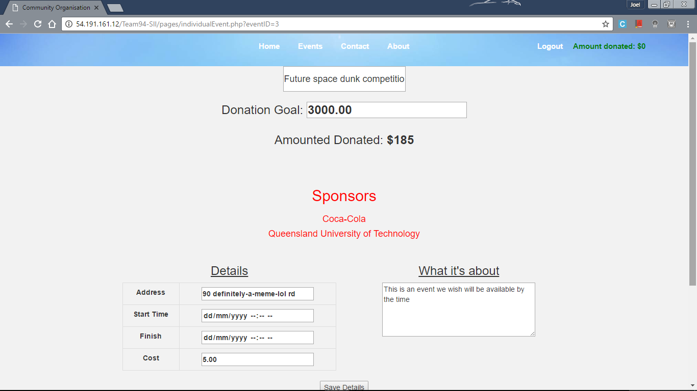

#### S10: Password Security

As a sponsor, I want to ensure that my password and other details are protected so that I can navigate the website safely

**Acceptance Criteria:**

* When entering a password, a salt will be used to be concatenated with it before it’s entered into the database
* The salt will be a randomly generated series of numbers and letters

This task was completed so that all the user’s passwords are protected, and completed successfully, which is shown and proved in the picture below. It took one hour was the task to be programmed to a high level, maximizing the security levels. **Story Accepted**

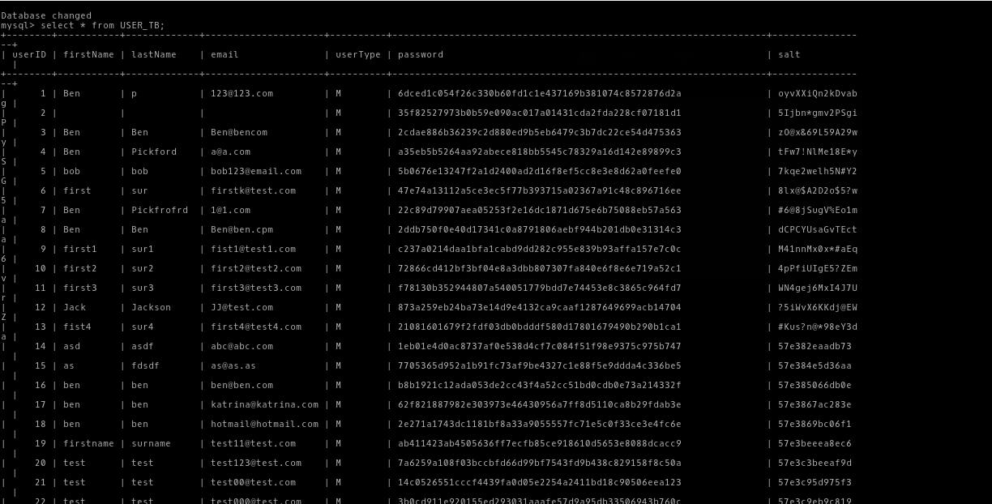

#### S11: Money Control

As a sponsor, I want to change the amount that I contribute so that I have more fluid control of my money

**Acceptance Criteria:**

* After a sponsor has already donated, they will be able to add more money using the same method they used before (max $500)
* The total will then increase by however much more is donated

To donate the sponsor must first register or login via the respected link on the top-right of the website. To donate to the chosen event the sponsor must navigate to the ‘individual event page’ via the ‘Event’ page, found on the navigation bar. On this page the user can RSVP to the event and donate towards it. **Story Accepted**

The story took four hours to complete, one hour shorter than what was estimated.

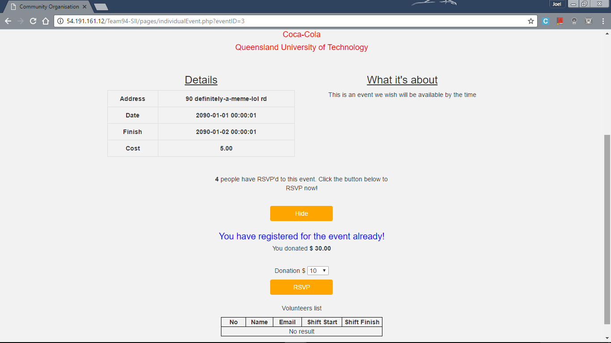

#### S12: Communication from Sponsors

As a sponsor, I want to know what time and date each event starts so that I will prepared to complete all the requirements before the event

**Acceptance Criteria:**

* The time and dates of the event will be displayed alongside the information for the event

Finding the time and dates of any event involves clicking on the ‘Events’ link in the navigation bar which displays all past, present and near-future events. This page shows the date of the event as well as the starting time. Clicking on an individual event allows the sponsor to view more information on the event. The story took one hour to finish, the same than what was estimated. **Story Accepted**

|  |  |
| --- | --- |
| Events Page | Individual Event Page |
|  |  |

#### S14: Security

As a volunteer, I want to ensure that my password and other details are protected so that I can navigate the website safely

**Acceptance Criteria:**

* For this to be accepted, when entering a password, a randomly generated salt will be used to be concatenated with it before it’s entered into the database.

Like story 10 this task was completed so that all the user’s passwords are protected, and completed successfully as shown in the picture below. It took one hour was the task to be programmed to a high level, maximizing the security levels. **Story Accepted**



#### S17: Giving Donations

As a donator, I want to be able to give donations online so that I don’t need to donate physically.

**Acceptance Criteria:**

* A PayPal (or similar) system is to be provided for making donations online securely and display up-to-date total donations when complete.

Any user who is registered and signed in can donate online for any individual event with use of the website, as shown below. **Story Accepted**

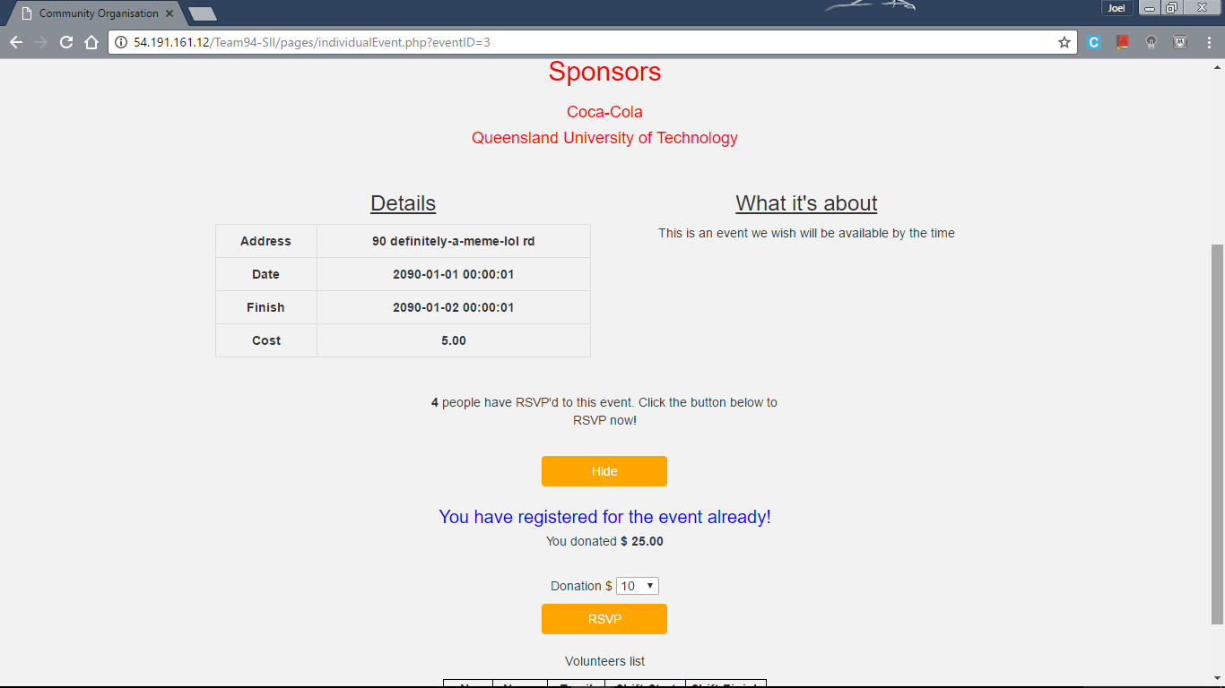

#### S72: Error Messages

As a developer, if something goes wrong I want to quickly be able to diagnose the problem through error messages so I can quickly debug and fix the website to ensure downtime is limited

**Acceptance Criteria:**

* Detailed error messages to cover most bases
* A 404 page should also be included

The website has a 404 page is the user makes a mistake in the navigate of the website. The page is shown below, which displays that the navigation bar is still visible and usable to the user to operate. Detailed error messages to cover most based was rejected due the criteria no longer being deemed necessary after a long and thoughtful discussion. **Story Accepted**

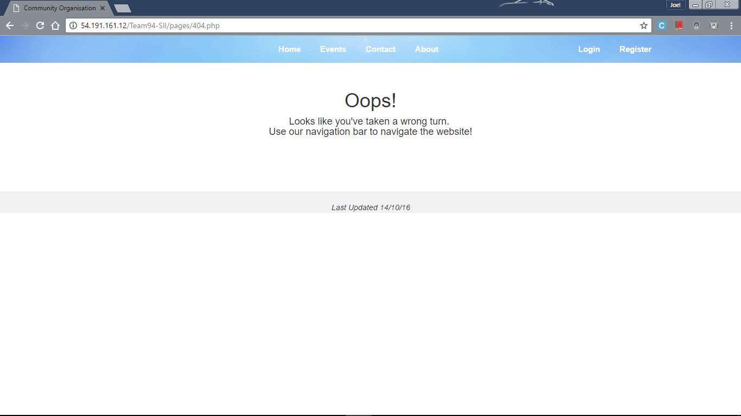

Testing the stories with their corresponding acceptance criteria

## Artefact 3 – Business Letter Editing

I edited the second business letter (peer review) in release 2. I made sure that the letter featured no grammar and spelling errors and when I did come across some I corrected it. By doing so improved our business letter’s structure and made it easier for the reader to read and understand what is being said.

|  |
| --- |
| **Client Team 94**  James Skidmore – n9146661  Benjamin McColm-Pickford - n8847762  Jonny Vukim - n9470921  Kihoon Seo - n8998949  Katrina Mallett - n9450866  Joel Perry - n9173471    October 18, 2016  Package Delivery Development Team 93  QUT Community Organisation  2 George Street  Brisbane, Queensland 4000    Dear Development Team:  I am writing to you as your client concerning the latest demonstration of your development project. On the the 13th of October 2016 your development team demonstrated the latest content and provided an update on the current version of the project and the technical work that has been completed regarding a website for the delivery company owned by Bill.  Much along the lines of the first progress presentation I would again like to commend your development team on their overall product so far. The team was prepared and confident in presenting the product and answering any questions relating to the development of the product to date. The presentation went along quite well except for one small error which was easily fixed. All story cards relating to this sprint were also discussed to see if the acceptance criteria was met or if any problems were encountered.  Continuing from your last presentation there was a set of expectations that were set regarding the content that should be completed and ready to be showed for the most recent presentation. It is my pleasure to inform you that your developed content so far has been far ahead of what was expected. Each of the story cards regarding the sprint plan were mainly completed and work that wasn’t expected to be done was also already completed or started to be worked on. The members presenting the product also came across extremely confident in the product they had developed to date and were able to explain anything regarding the product. The product is far ahead of what is expected and also delivers great business value. The group did come across some difficulties within this presentation regarding sprint 4 material, this was resolved by showing one part of the website on a local machine as the product wouldn’t get pushed to the final website for an unknown reason. This was not an issue though as this part of the product wasn’t meant to be shown yet and shows the confidence and ability your team has in developing this product.  . In addition to this one user story that was set to be released within this sprint was not completed due to the team no longer finding this user story necessary due to a change of plans, this was carefully and meticulously explained to us as the clients and we are happy and respect their decision not to move forward with this user story.  During the product demonstration no technical difficulties occurred as the presentation was presented at the right level for all the stakeholders. The system architecture explained by the developing team was well defined and shown to be suitable for the project with no defects in the presentation detected. Your team has gone ahead and researched everything and discussed why you made these choices so I am unable to provide much feedback regarding ways to improve as your product is of an extremely high quality already. As stated previously, there was a small issue regarding the routing aspect of the product but that was solved by demonstrating it on a local machine.  The professionalism of the presentation requires improvement in the future as a more formal and rehearsed presentation is expected throughout the rest of the project, however, all content was covered with quality information. The members presenting the product were coherent and confident in their knowledge of the product to date. Each question regarding the product and how the work was completed was answered to a satisfactory level with every member of the development team seeming to be involved in helping create the product. As the presentation was performed ad hoc it did mean that there were some parts that were probably not discussed to their fullest potential but this can be easily fixed by spending a short time preparing well for the presentation.  Recommendations for the team moving forward is to obtain a higher level of professionalism when producing their work to match the strong content provided and to ensure that all issues with user stories are identified and notified to us as the client team as soon as possible.    In conclusion, the presentation of the product was conducted at a high level by the development team. The demonstration was clearly prepared and provide us, as the client, with knowledge that the project is keeping to the precise time schedule and completing mostly all required story cards with their acceptance criteria.    Sincerely,  Bill’s Delivery Service Melbourne |

## Artefact 4 – Individual Efforts during Release 2

In release two I constructed a chart for each sprint displaying how much work each group member accomplished. The charts allowed each member of the team to see what the rest of the group is achieving in their work. The chart from sprint 3 allowed feedback to the group that we need to even out the work around the team more evenly. This is did as shown in the chart for sprint 4.

## Artefact 5 – Critical Reflection

I wrote up a critical reflection on our group in release 2 based on what we achieved in the release. The reflection shows how we progressed through the stories in the release and the end result for the group.

The Release 2 Burndown chart (shown above) shows that the team fell behind at the start of the Release as well as the end, however we still finished all the stories by the end of the release. During the middle of release 2 the team kept to schedule, recovering from the poor start to hover around the ideal burndown line for around 15 days in the middle. The reason why a lot of story points where left to do at the end was due to the difficulty for the tasks required to finish the two stories. Story 17 was worth a high 16 story points and therefore took a lot of discussions and experimenting to complete. However, all the of stories planned to completed for release 2 were completed at the end and proved in the testings to be produced at a high level.